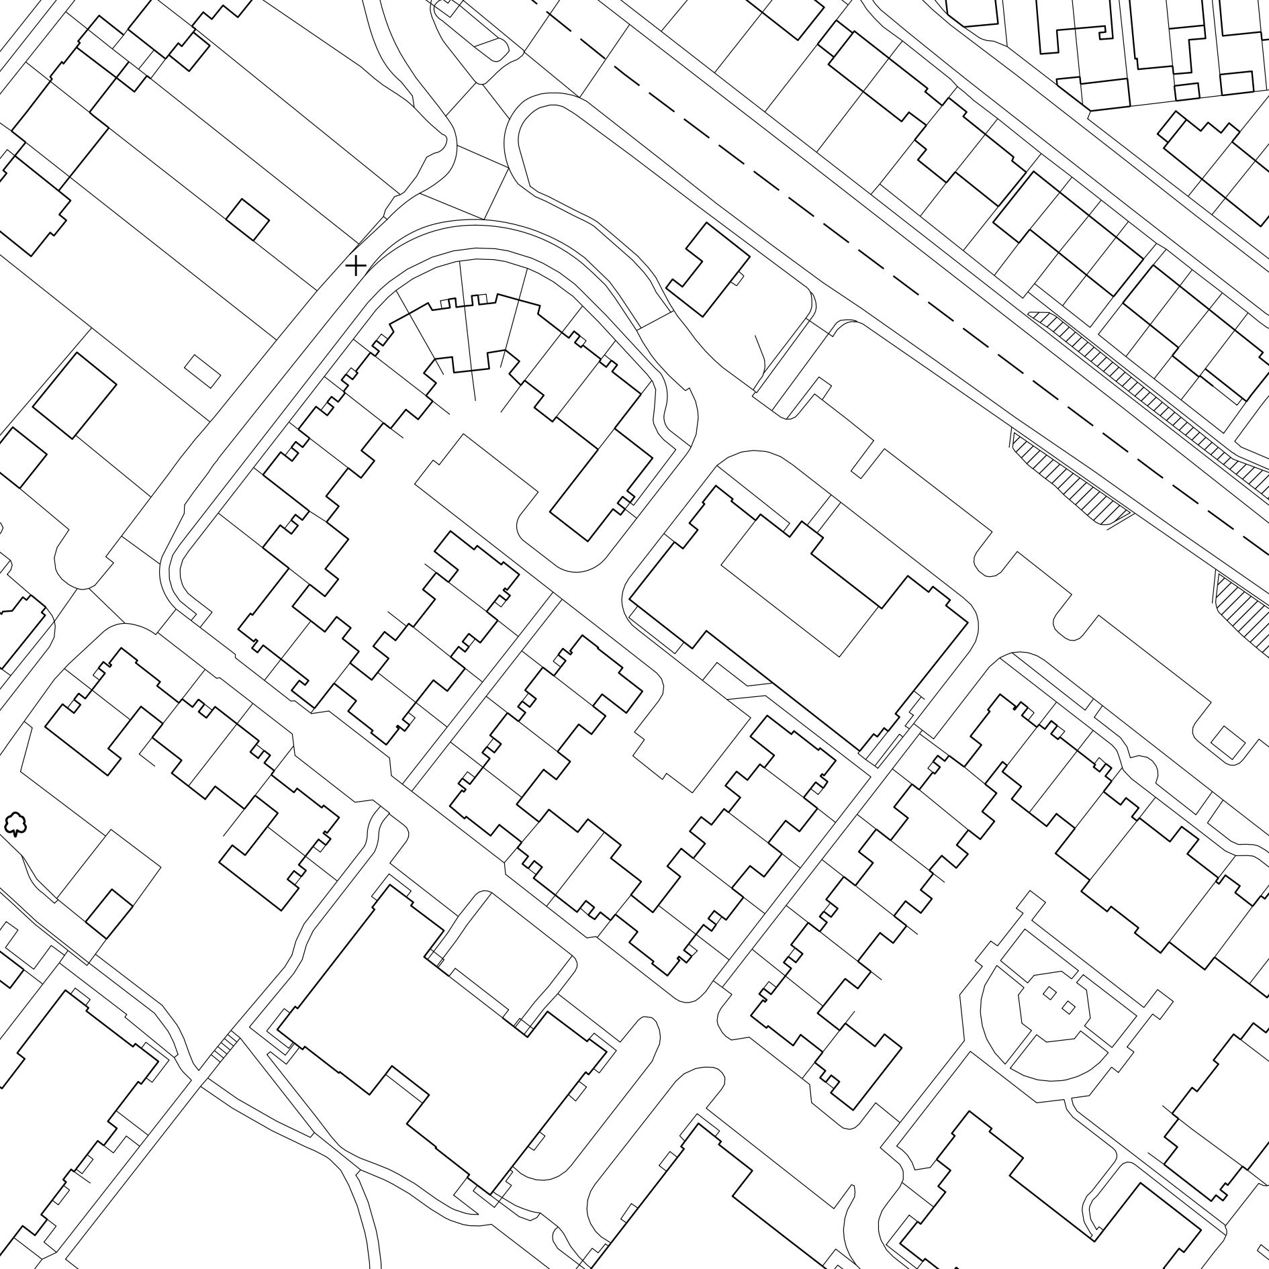

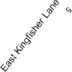








Supplied by: www.ukmapcentre.com



Product Info: www.ukmapcentre.com/location-plans-1250-scale

